1. Upload hr_db dataset into HDFS

2. Solve the following use cases using Hive SQL or Spark RDD or Spark DF (Pick any one of these)

a. Retrieve last_name, first_name, salary, salary+300 as increment salary from employees table

b. Find out the ID's of departments in which employees are working

c. Retrieve last_name, job_id, department_id of employee having last name as Whalen

d. Retrieve last name and salary of all employees who have salary greater than 5000 working in department 90

e. Retrieve last_name, salary of all employees working as 'SA_REP','AD_PRES' earning above 5000, sort the data in ascending order of last name

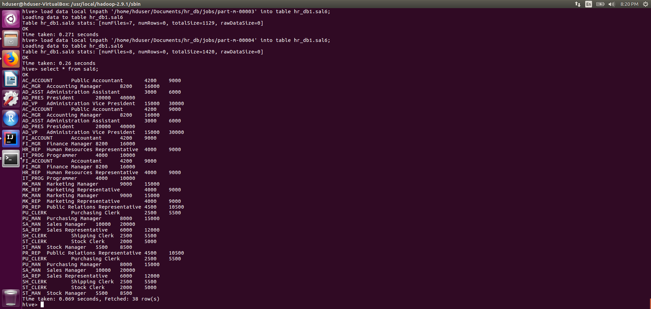

f. Retrieve the last names of employees whose last but one character of the last name is e

g. Retrieve the names of employees not having managers

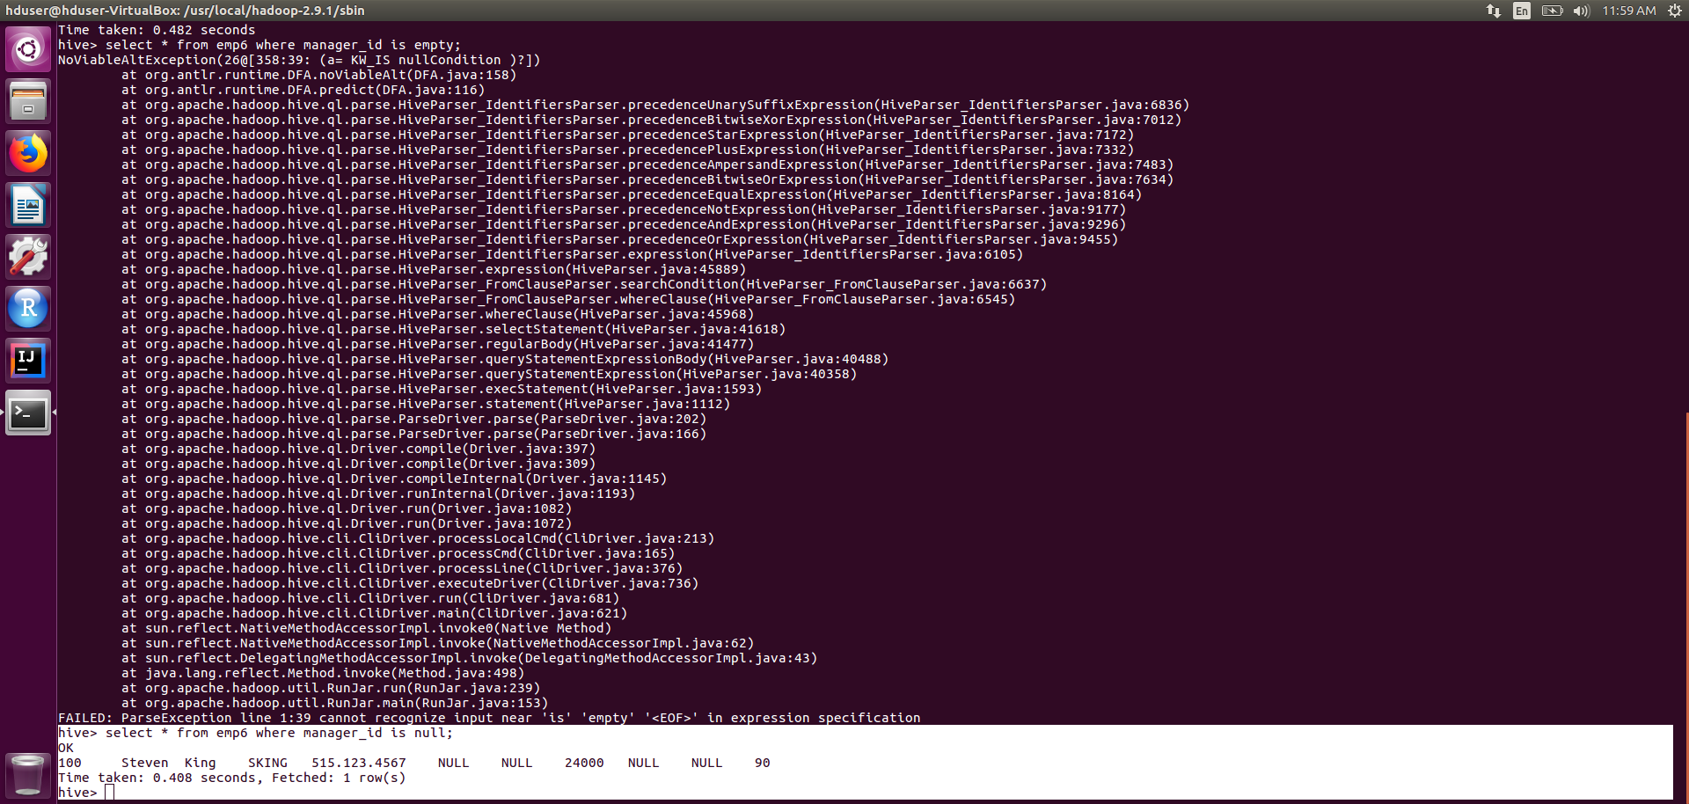

h. Retrieve the employee name and the name of the department in which the employee is working

1. List all the department ids having SIX employees

